**Customer Contracts Configuration UNU:**

Customer Contracts 9.0 Configuration Workbook

(includes related Billing/Grants/GL/Customer/PeopleTools Security configuration)

Installation Option:

**Navigation: Set up Financials/Supply Chain > Install > Installation Option – Products:**

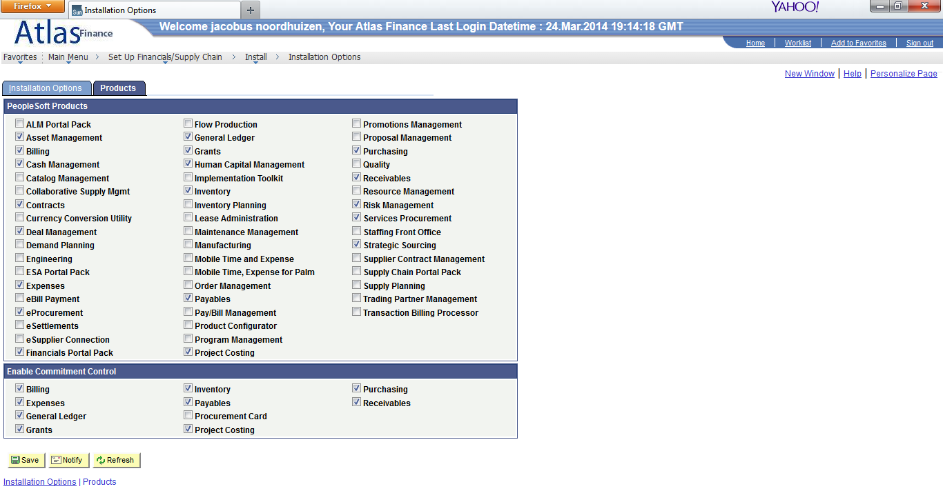

**Already set up for UNU in production**

**Navigation: Set up Financials/Supply Chain > Install > Installation Option – Contracts**

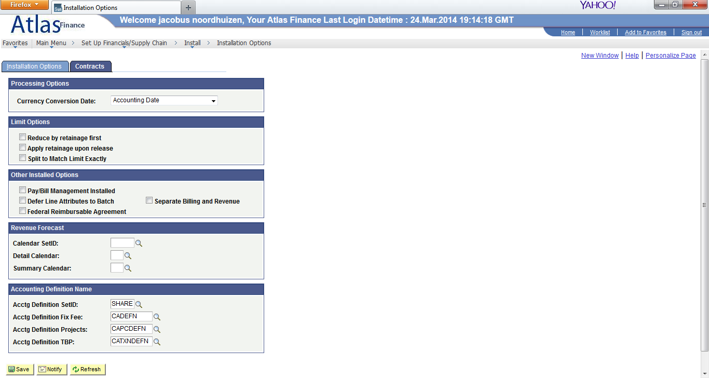

**Already set up for UNU in production**

Distribution Codes (per GLBU):

**Navigation: Set up Financials/Supply Chain > Common Definitions > Distribution Accounting > Distribution Code**

Page DST_CODE_TABLE

Component DST_CODE_TABLE

Create Distribution Codes:

* AR (not set up for UNU)
* DFR_REV (not set up for UNU)
* UNBILL_AR (already set up for UNU in production, but **different** GL account )

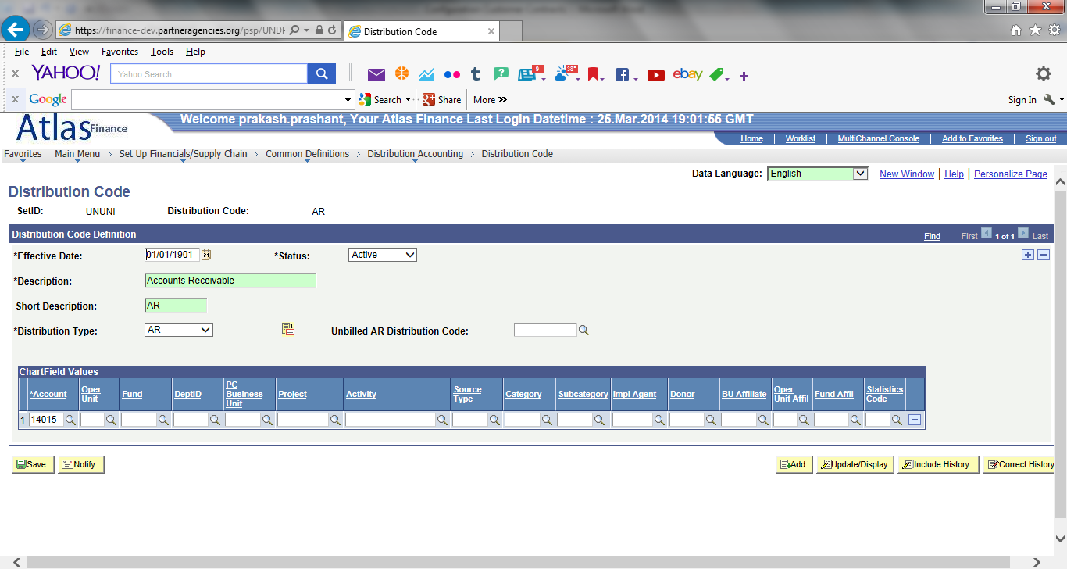

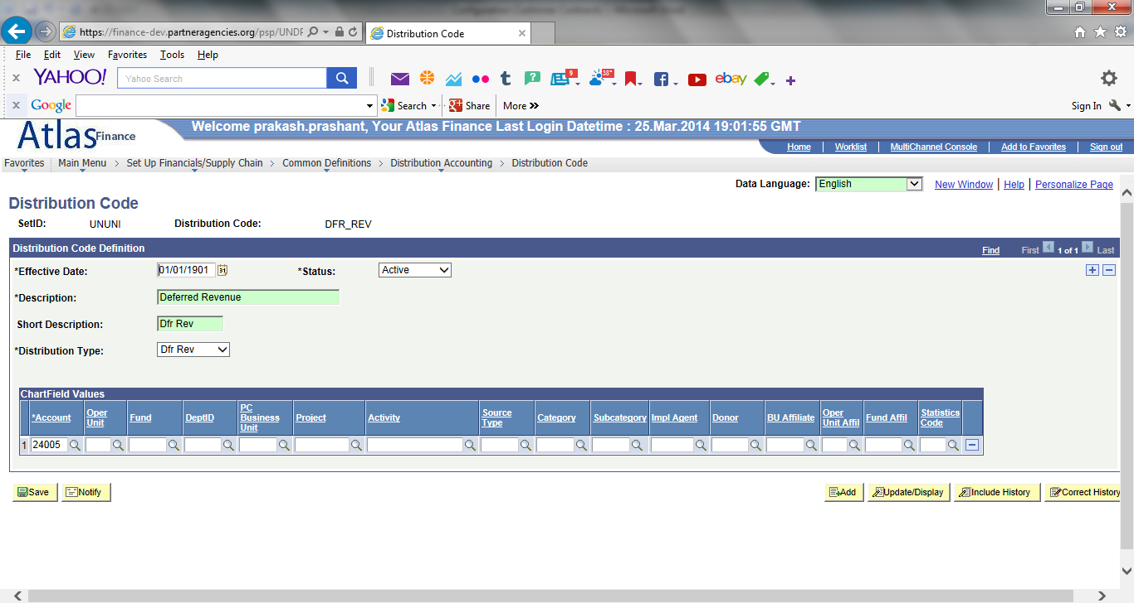

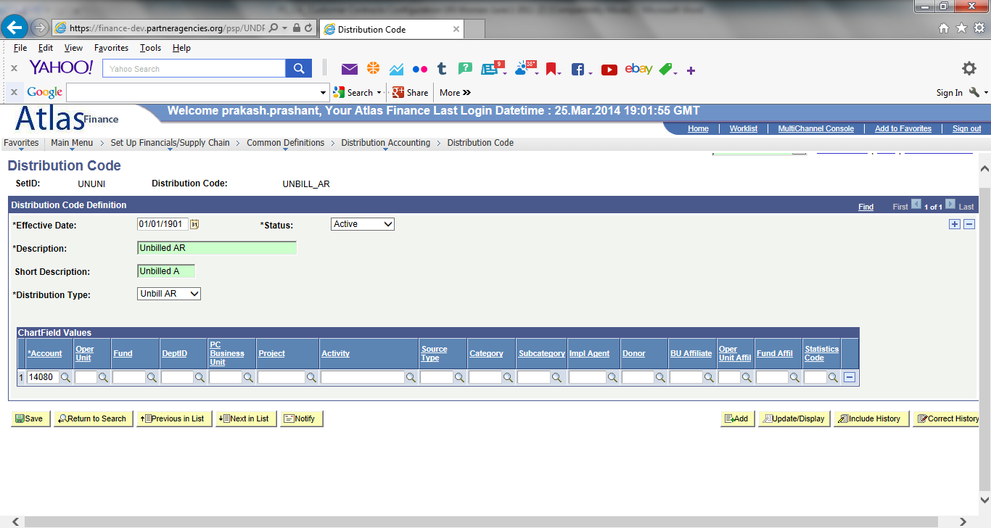

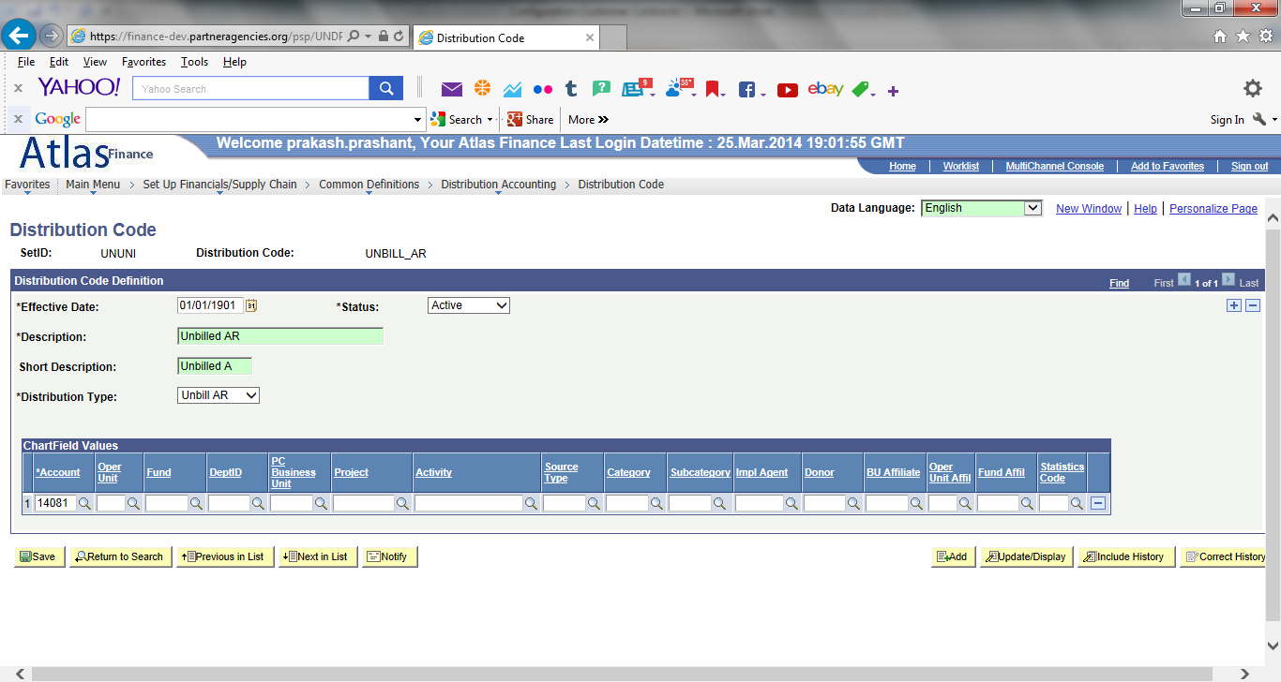

**Navigation: Set up Financials/Supply Chain > Product- Related>Contracts > Templates > Bill Plan Detail Templates:**

Set up for UNU but blank Bill Type Level Details

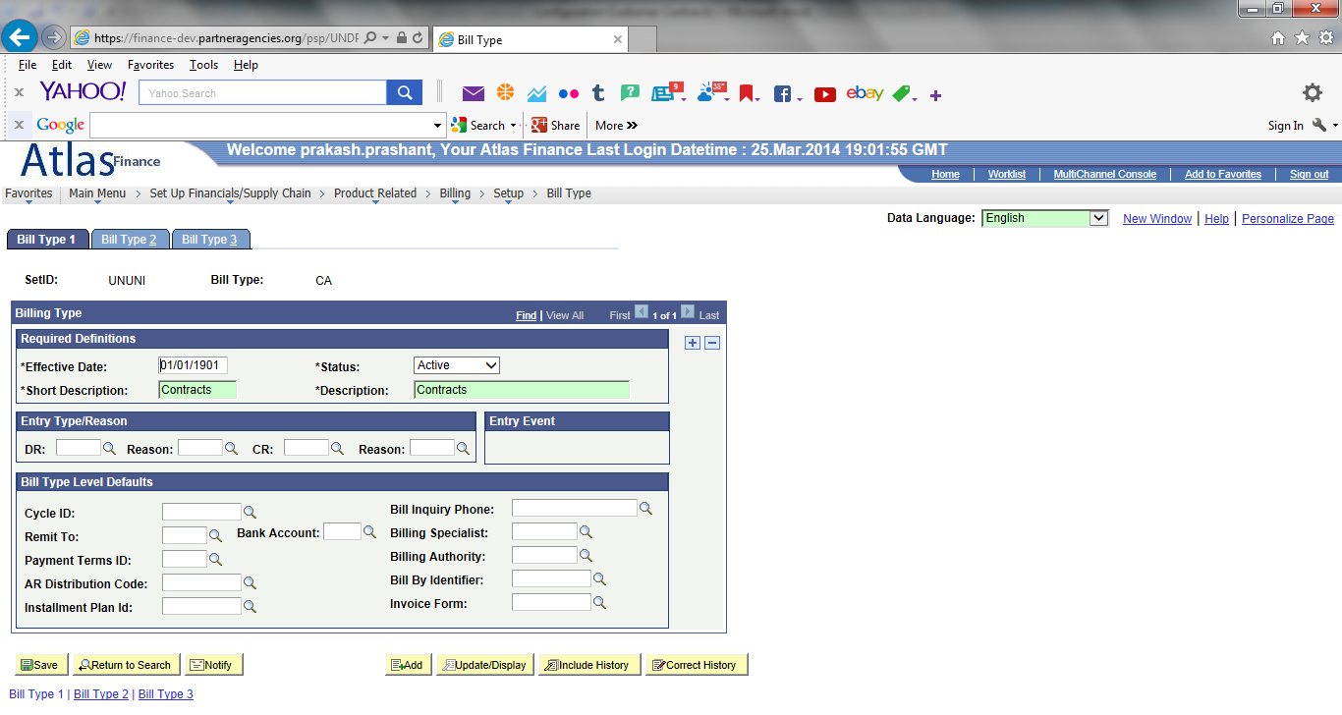

Bill Type Level Details not set up for UNU

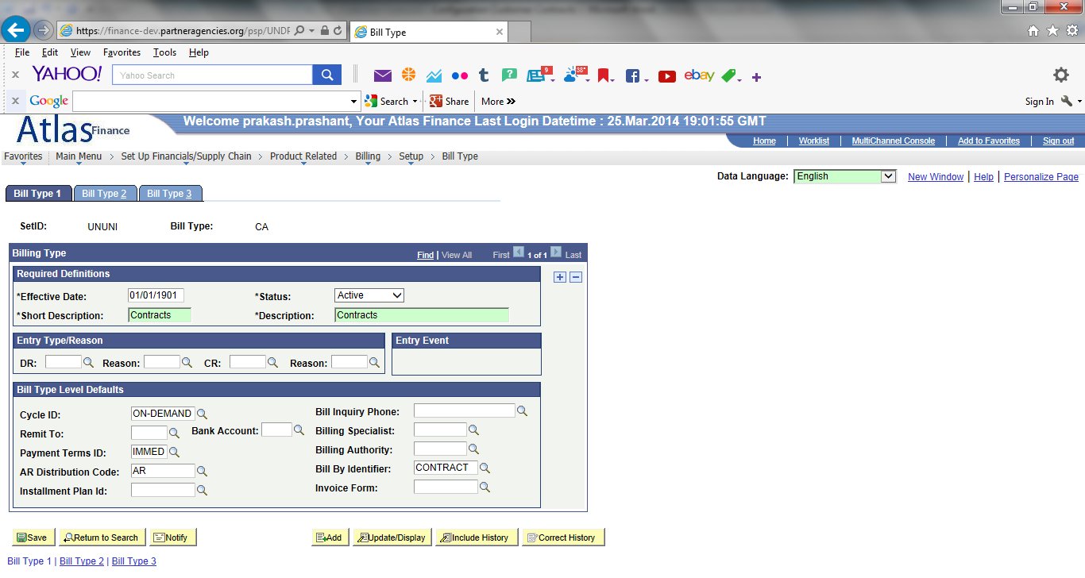

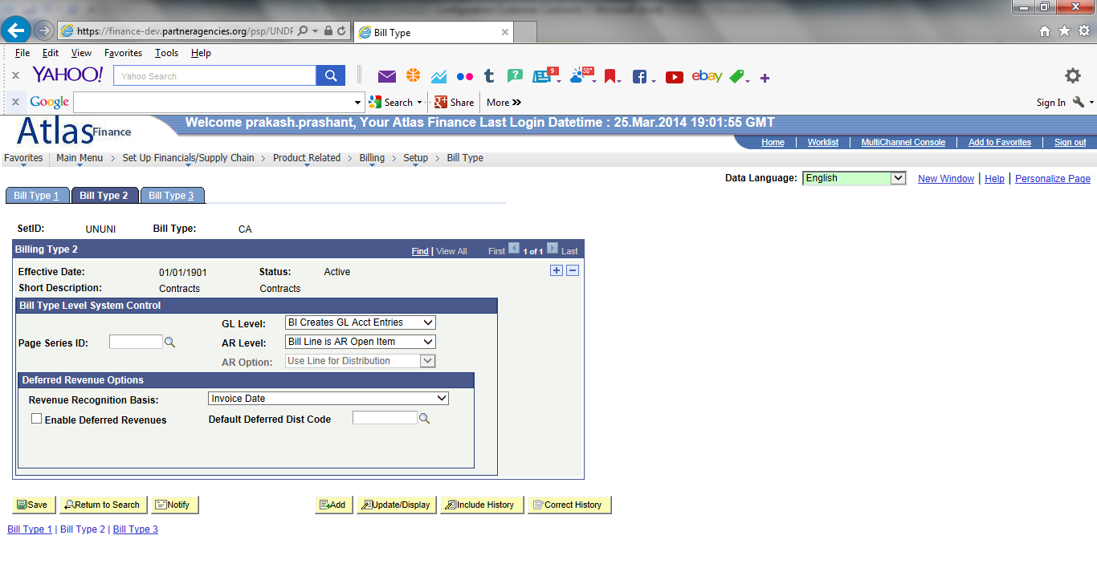

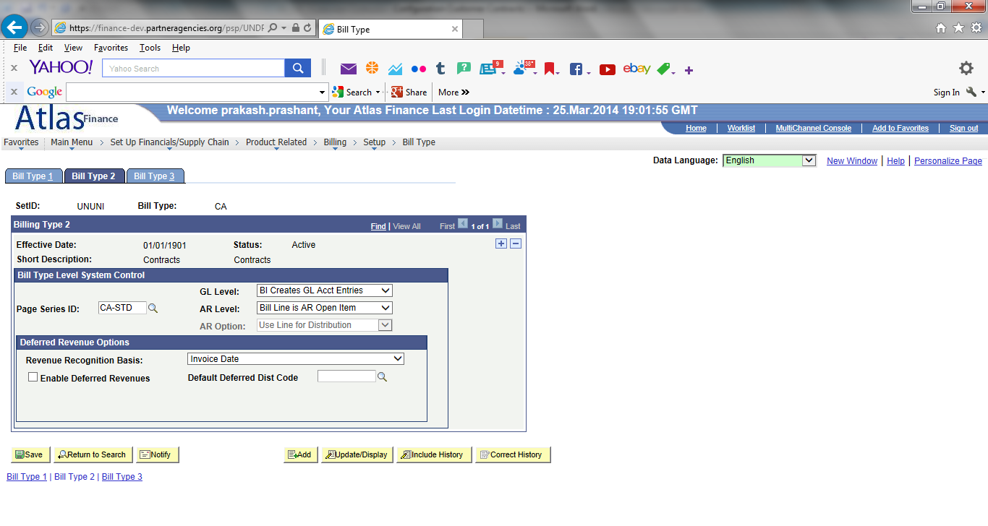

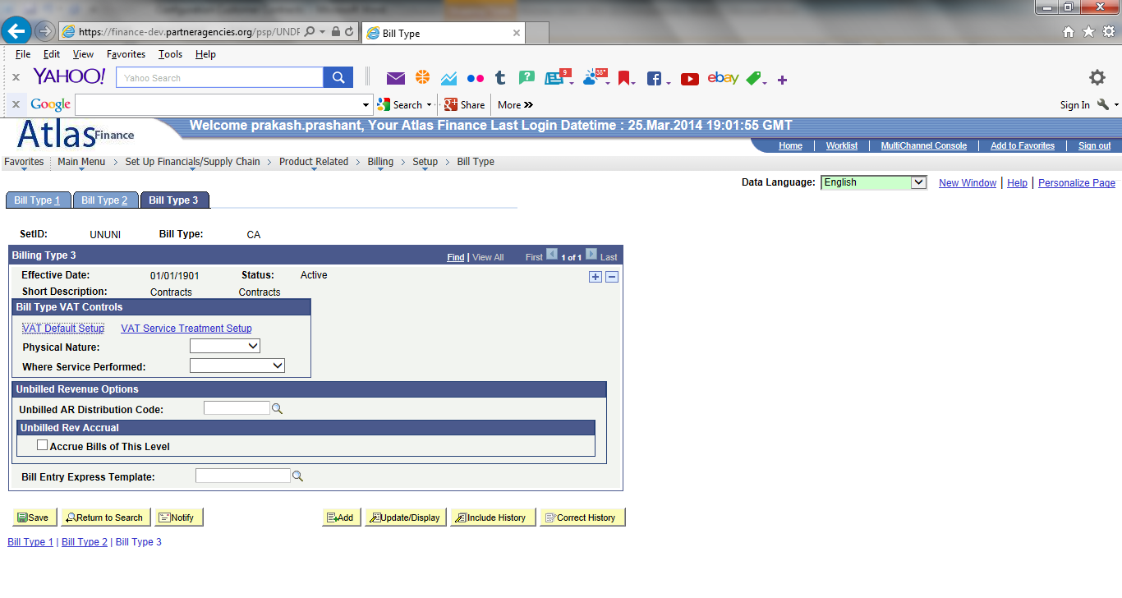

**Navigation: Set up Financials/Supply Chain > Product- Related > Contracts > General Options > Contracts GL Options:**

Set up for UNU but blank Journal Templates

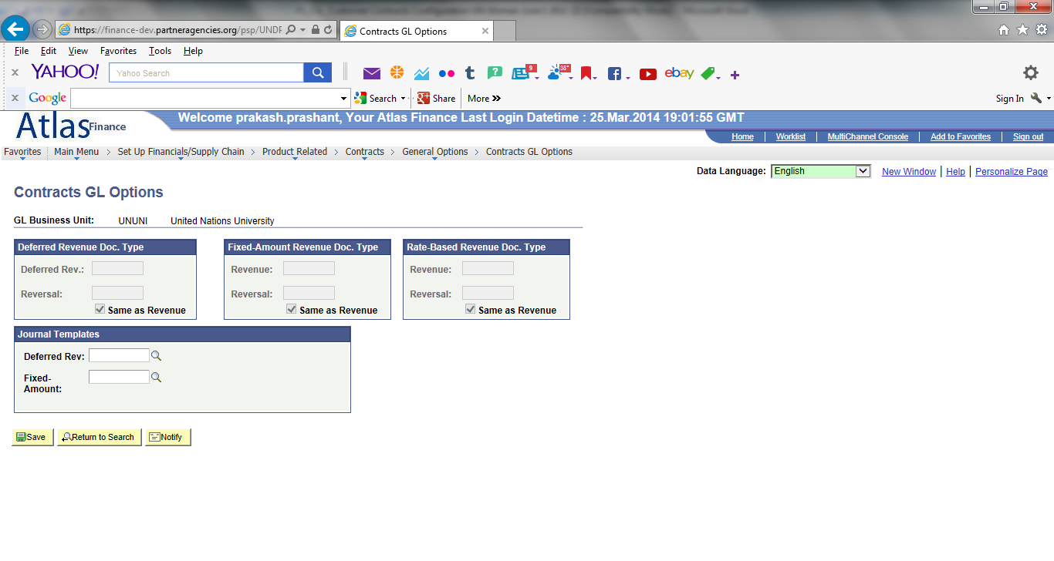

Journal Templates not set up for UNU

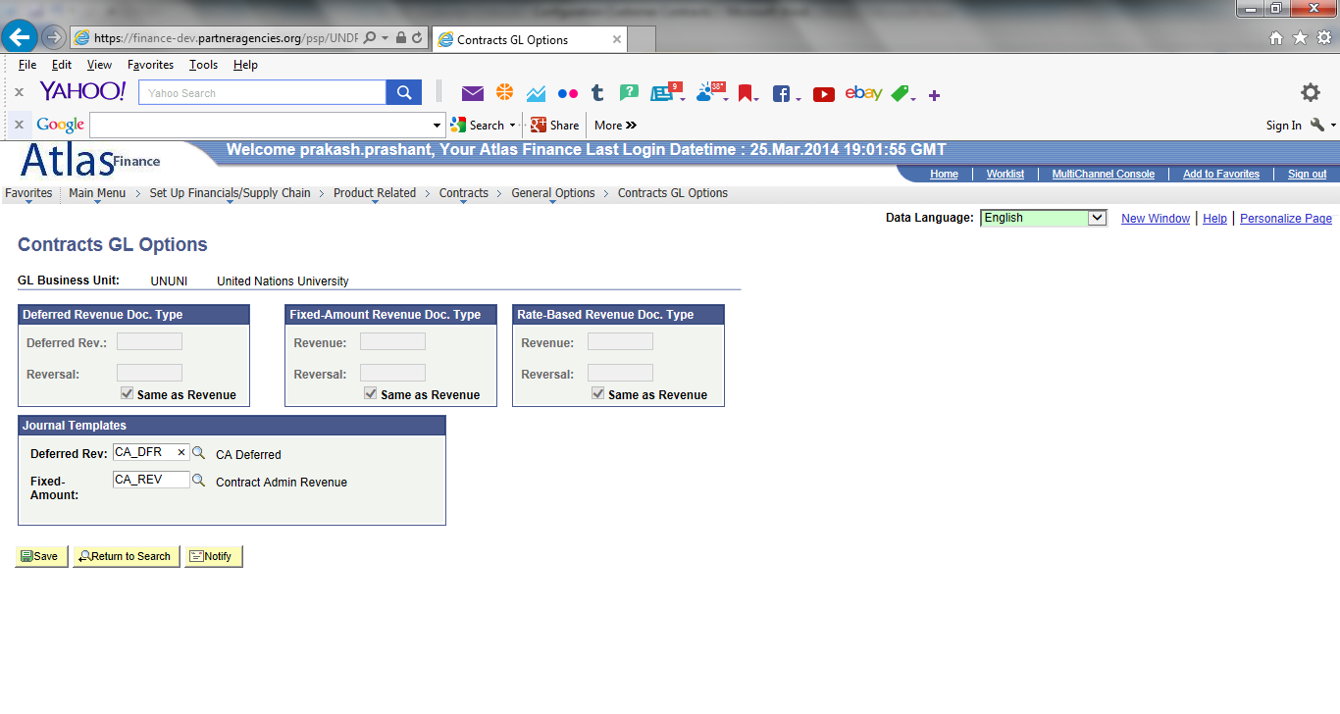

**Navigation: Set up Financials/Supply Chain > Product- Related > Billing > Setup > Bill Type > Bill Source:**

Set up Bill Source:

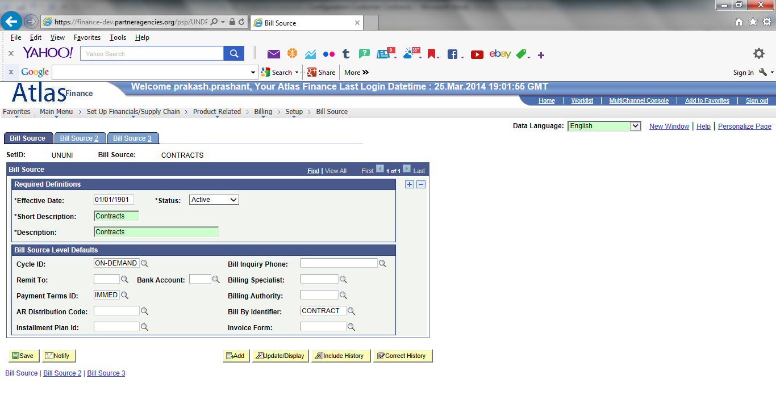

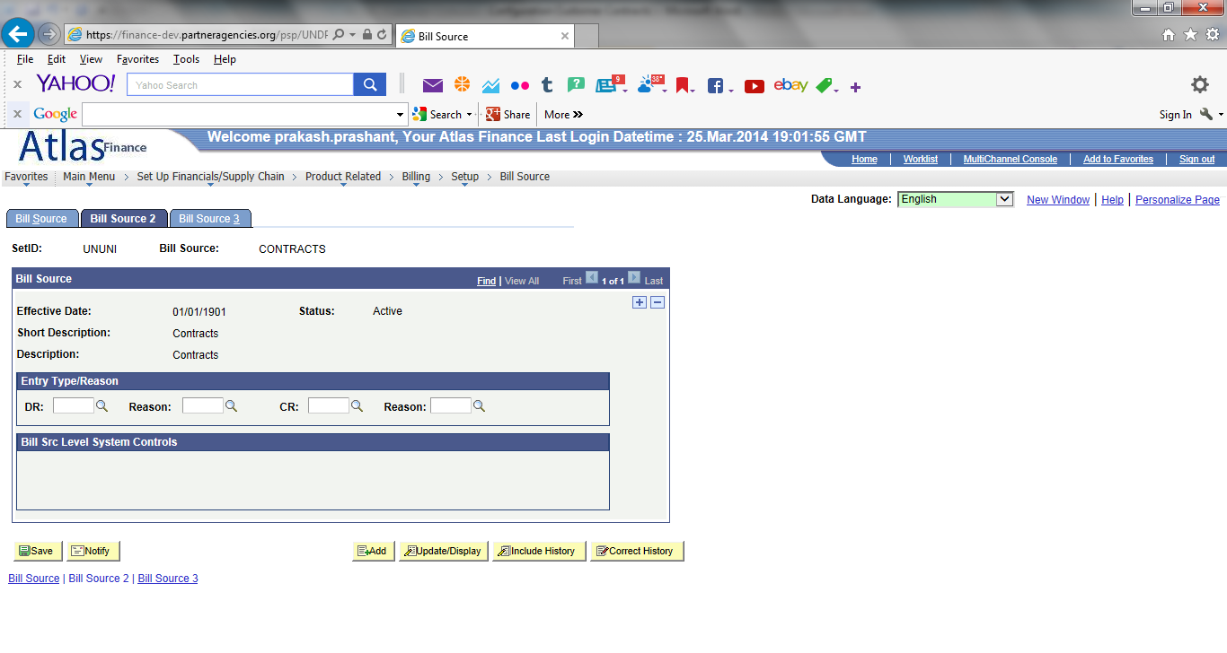

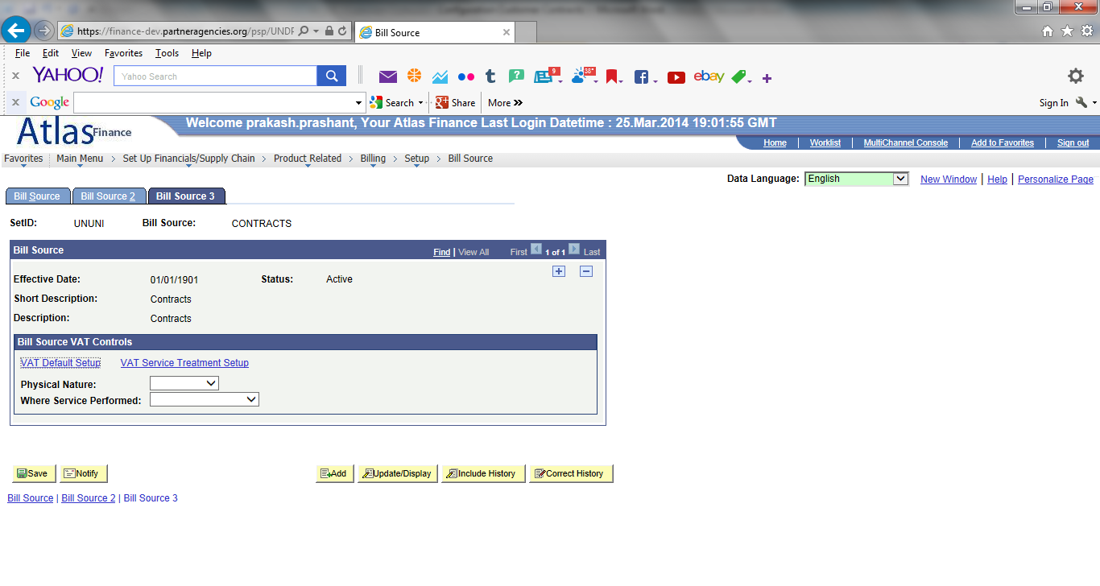

**Navigation: Set up Financials/Supply Chain > Product- Related > Billing > Setup > Invoice Number ID:**

Set up Invoice Number ID:

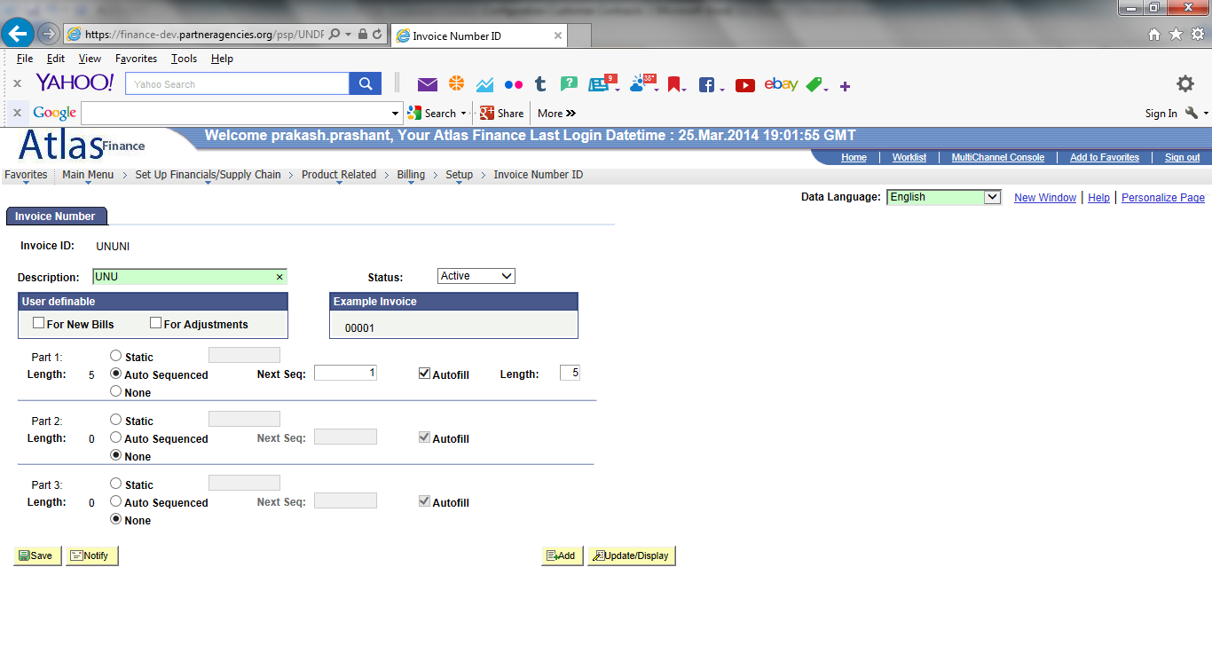

**Navigation: Set up Financials/Supply Chain > Business Unit Related > Billing > Billing Definition:**

Set up but incorrect Invoice Number ID (UNDP)

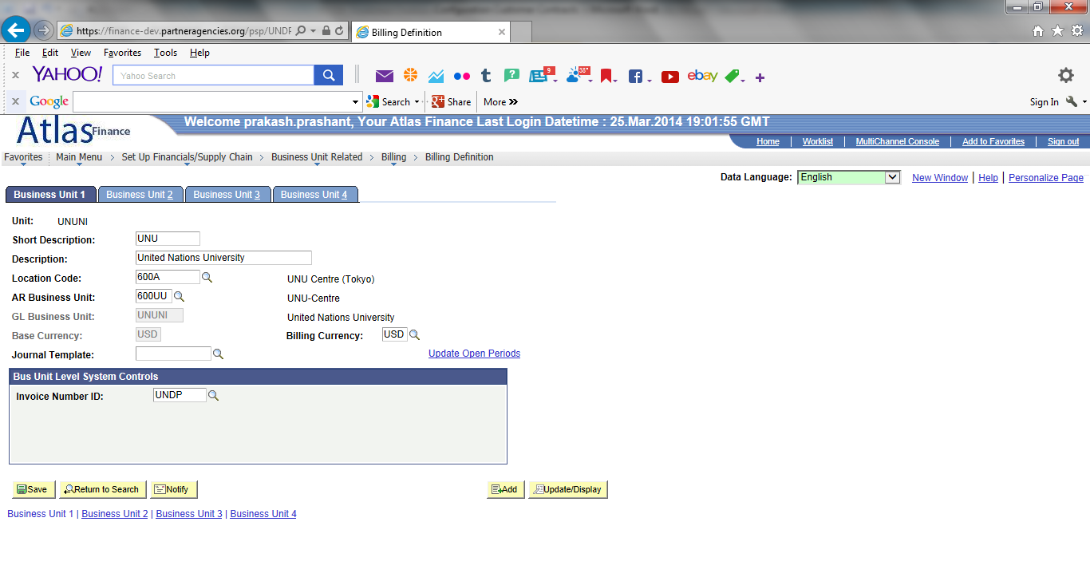

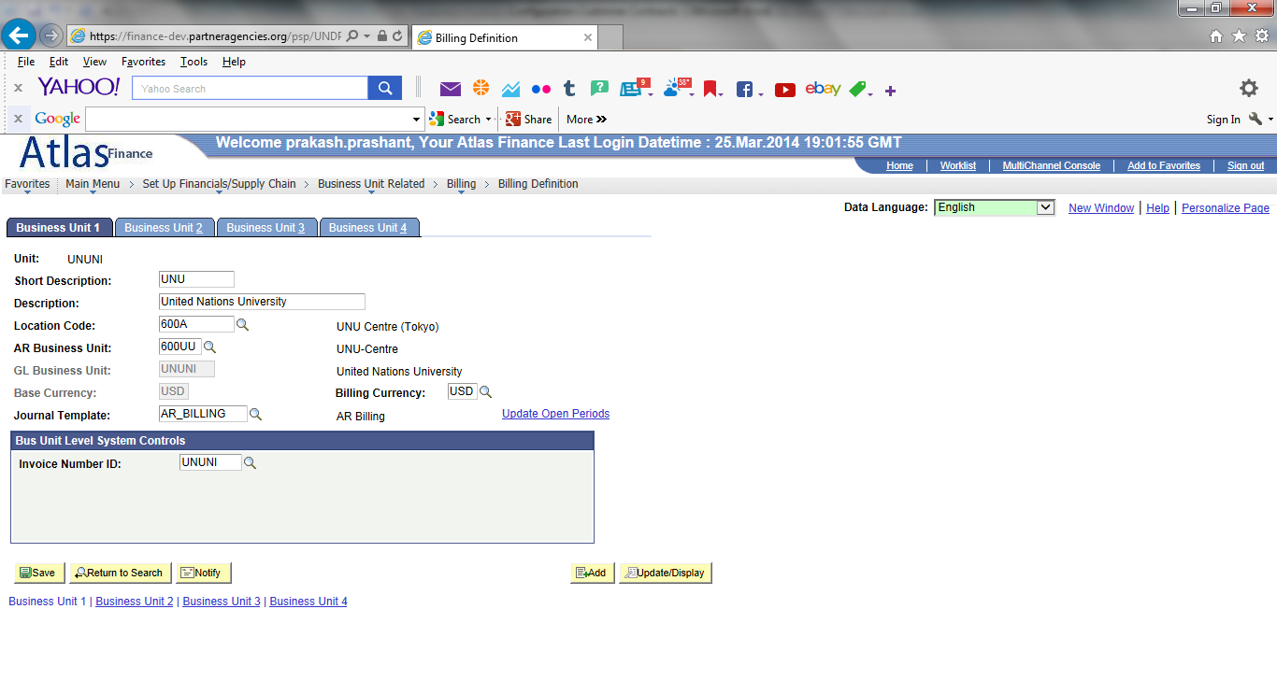

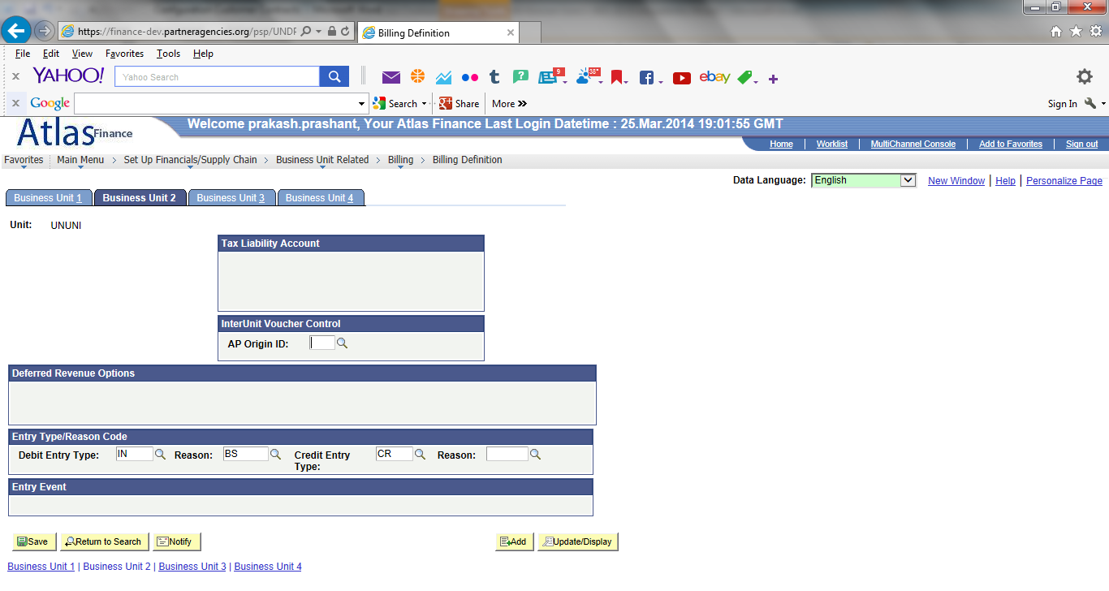

UNFEM configuration: Reason code is blank field.

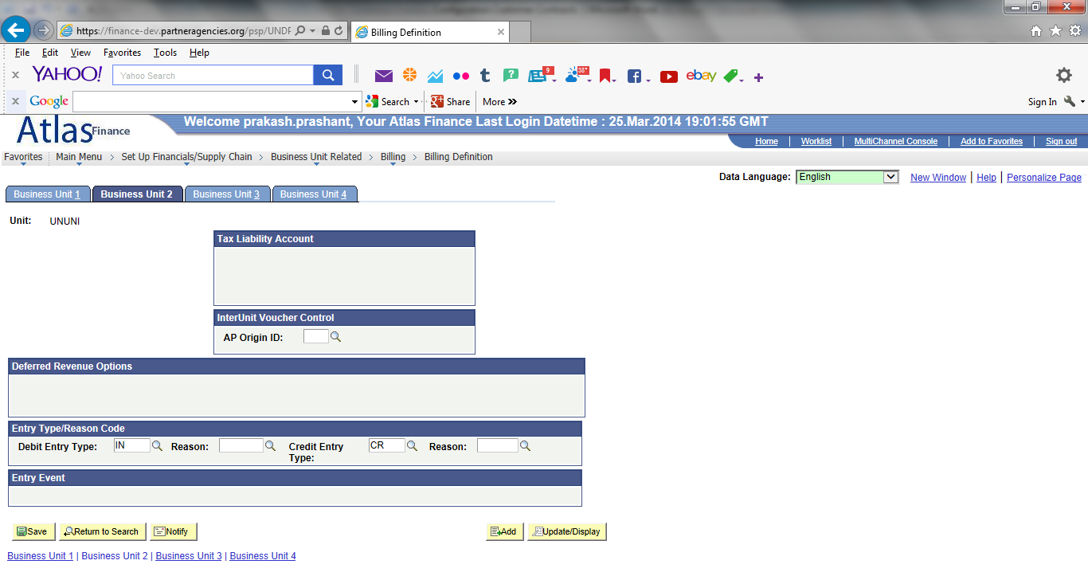

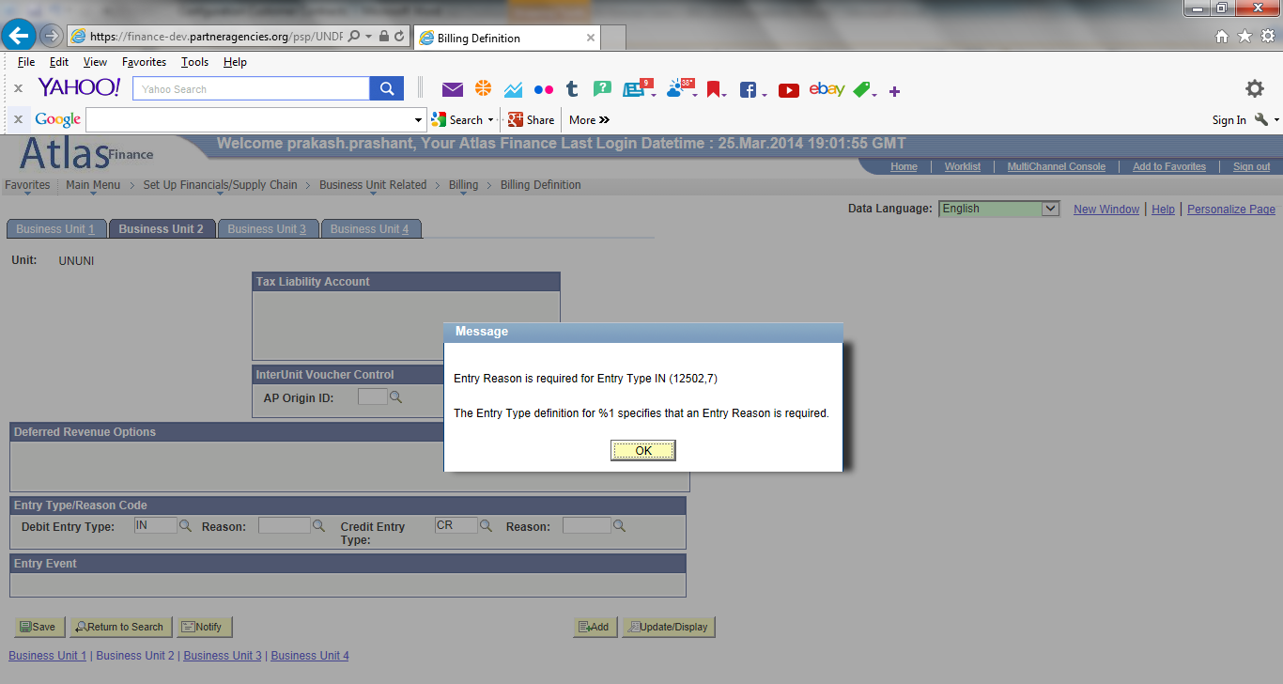

Error message Entry Reason is required

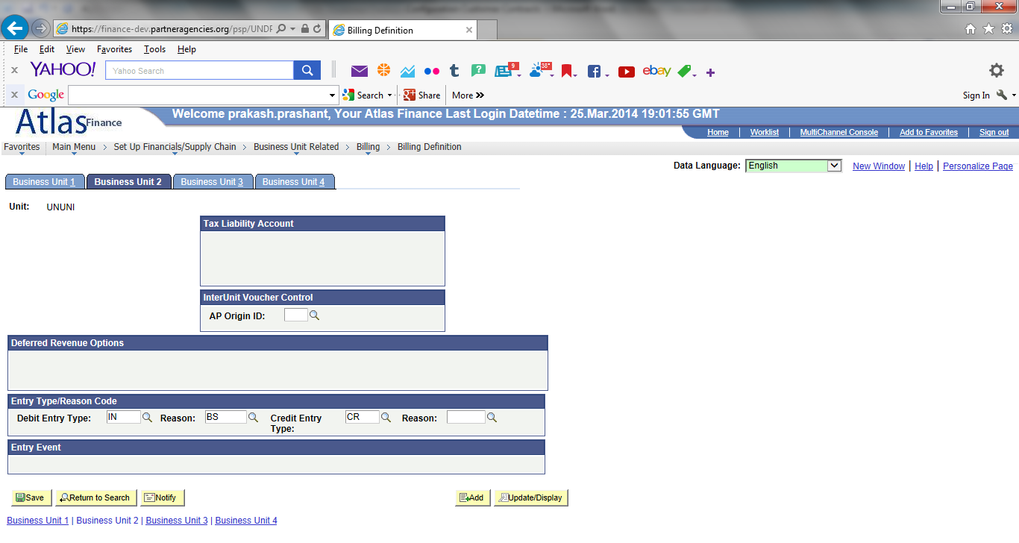

Saved with Reason Code since it is required field: **BS**

**Navigation: Set up Financials/Supply Chain > Business Unit Related > Billing > Billing Options:**

Set up for UNU but blank fields and incorrect values:

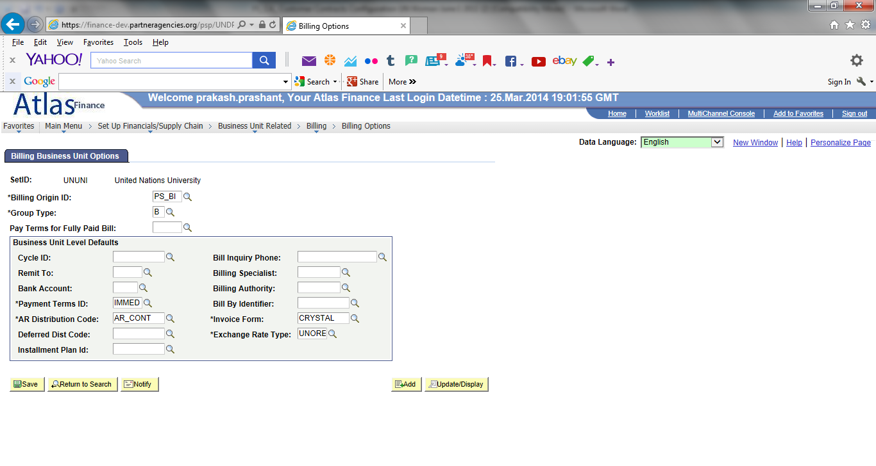

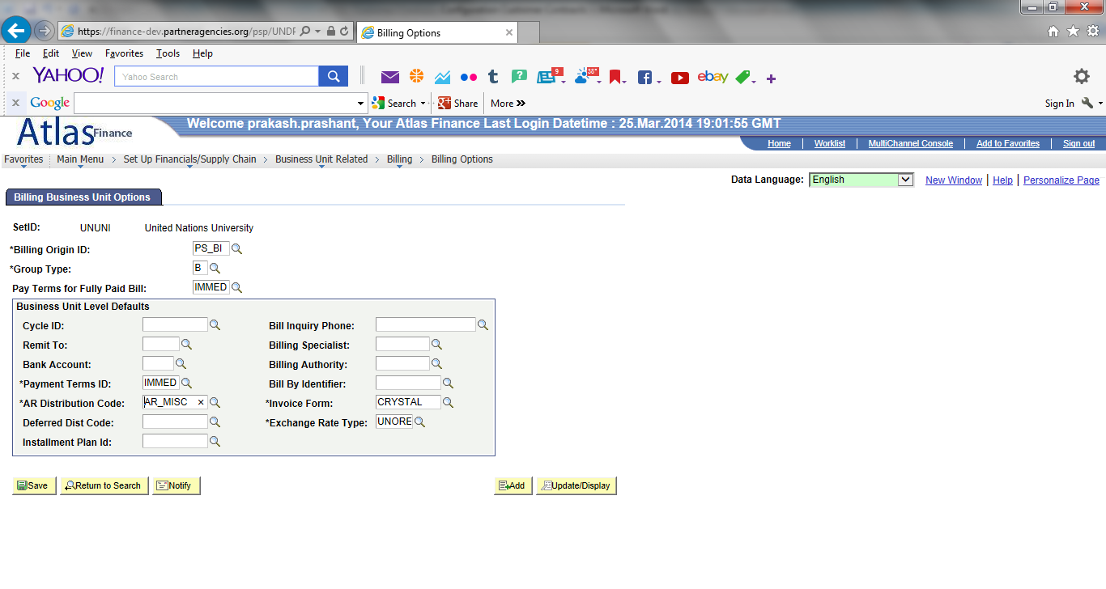

Remit to and Bank Account left blank

**Navigation: Set up Financials/Supply Chain > Business Unit Related > Contracts > Contract Definition:**

Set up for UNU but with blank fields or incorrect values.

Error message: description is required field.

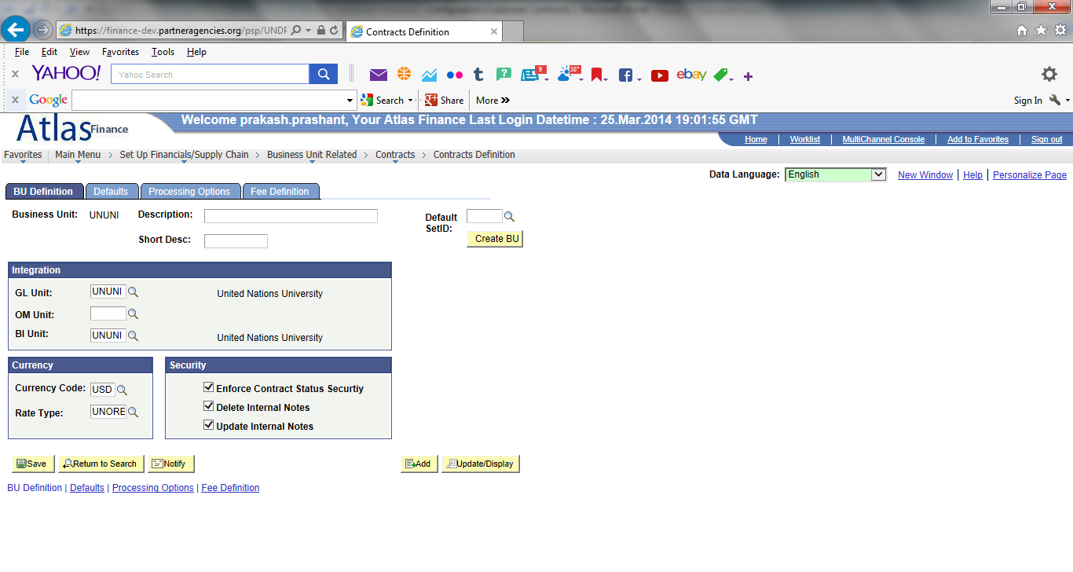

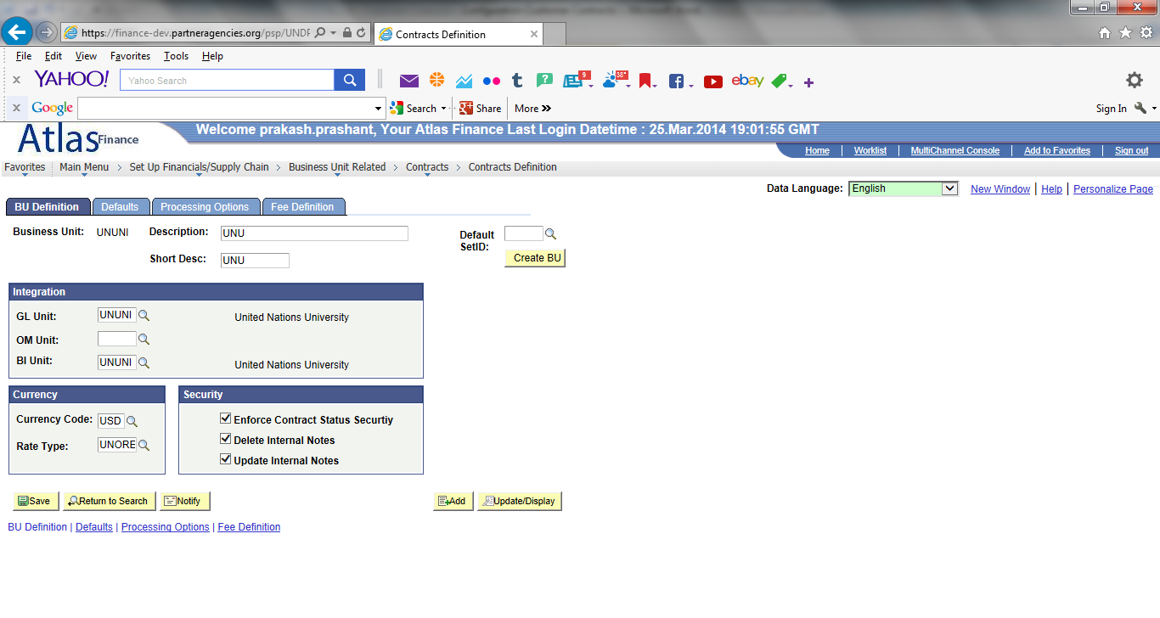

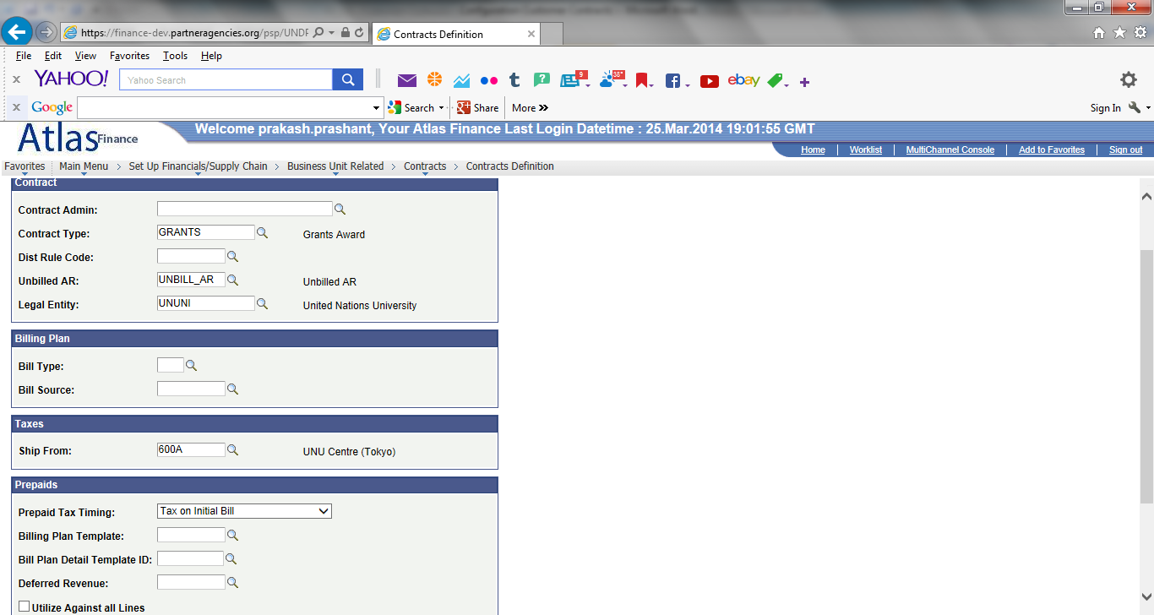

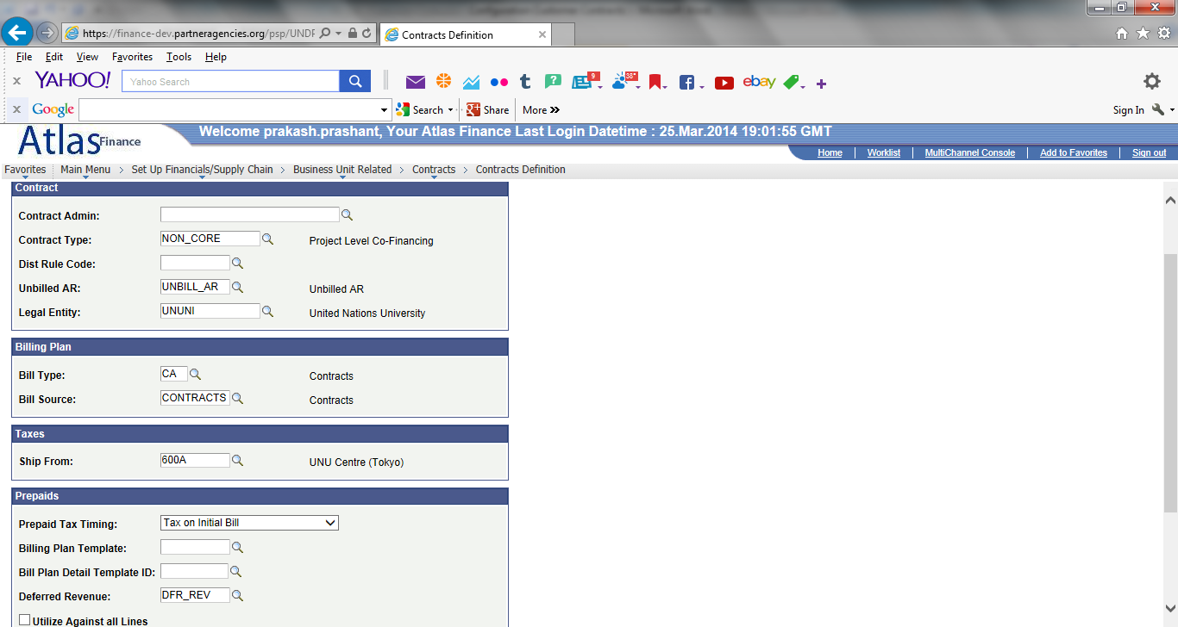

Review Bill Type and Bill Source:

For UN Women: CA and CONTRACTS

For UNDP1/XXX10: blanks

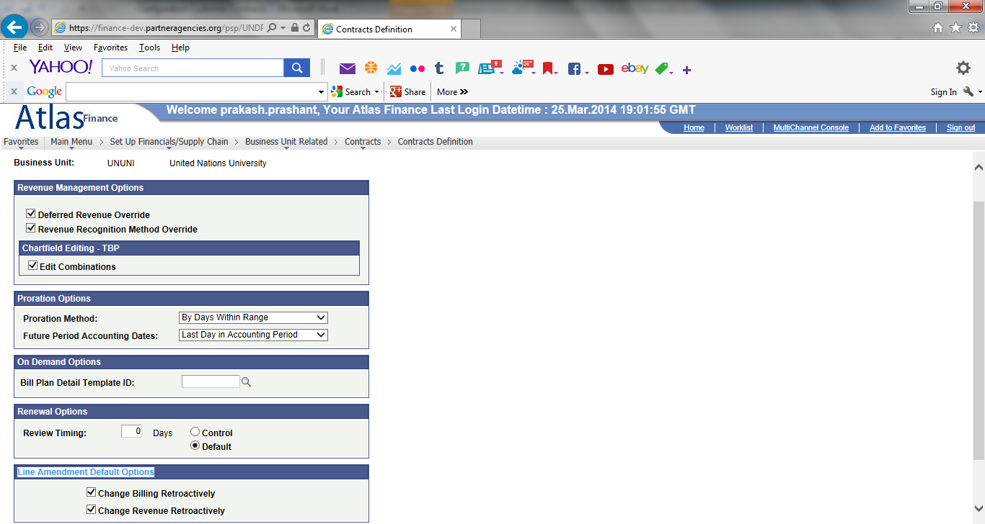

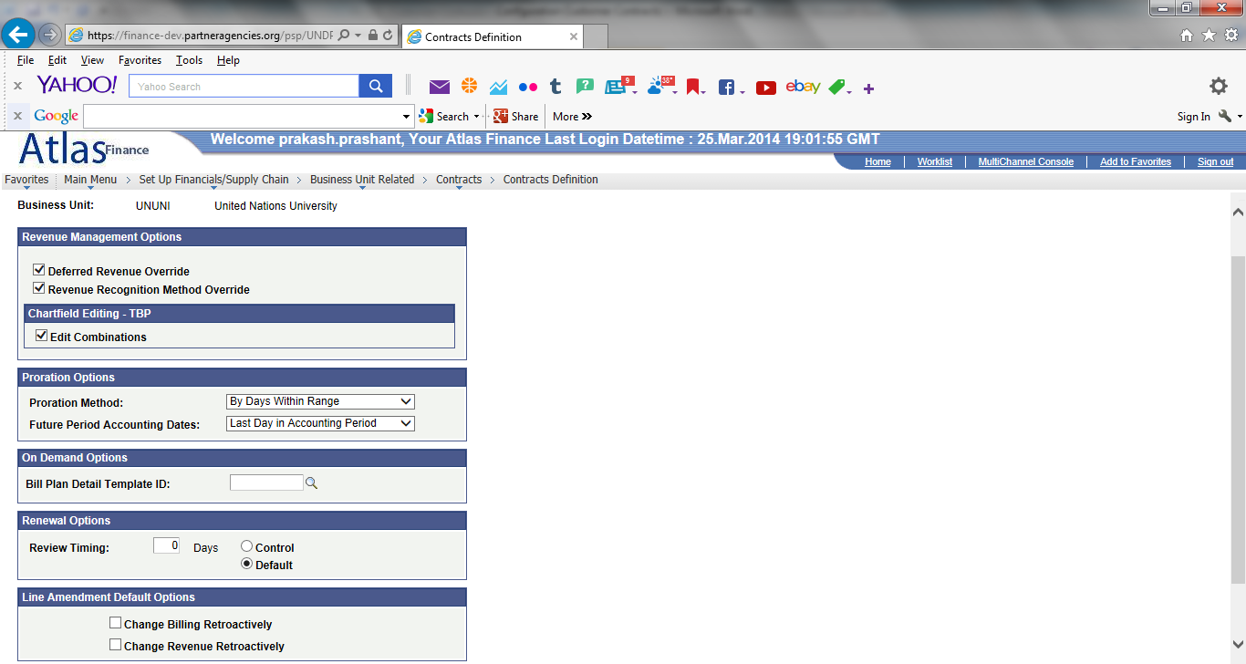

**Navigation: Products > Identify Product Details > Definition:**

Set up CORE, NON CORE, NON CORE EC (not set up for UNU), and NON CORE NON STD (not set up for UNU) for UNU:

Some UNU products are available in production but need to be adjusted!

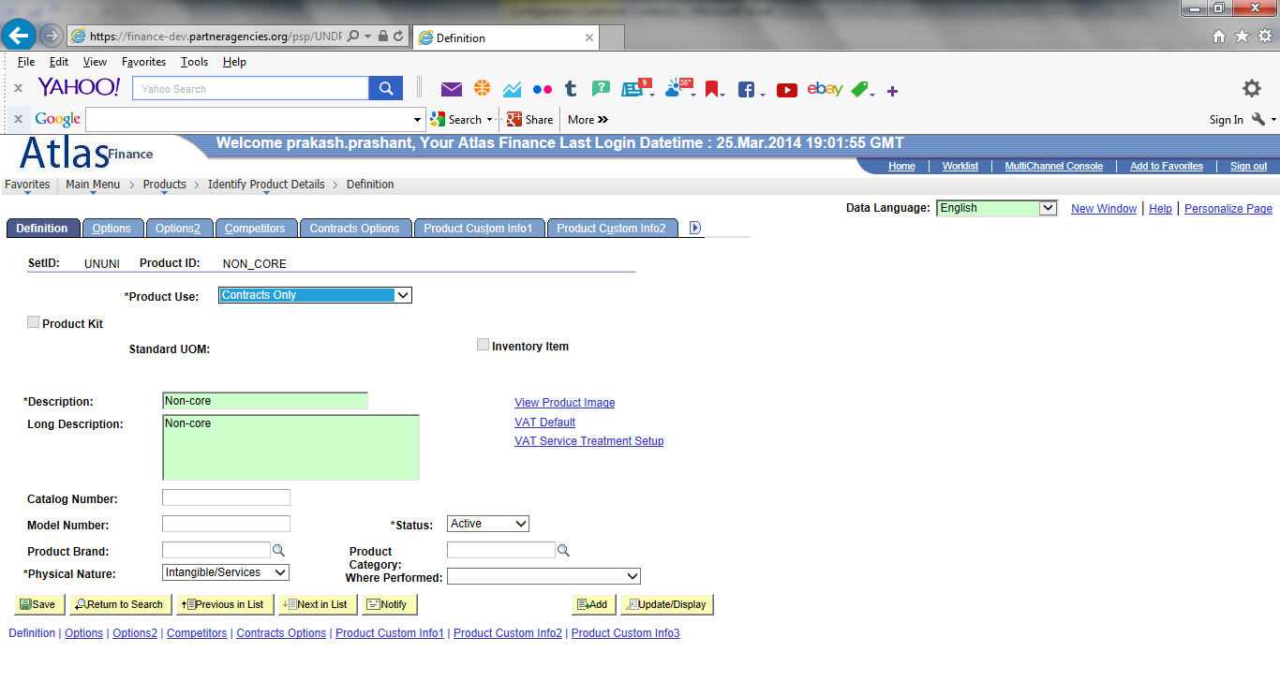

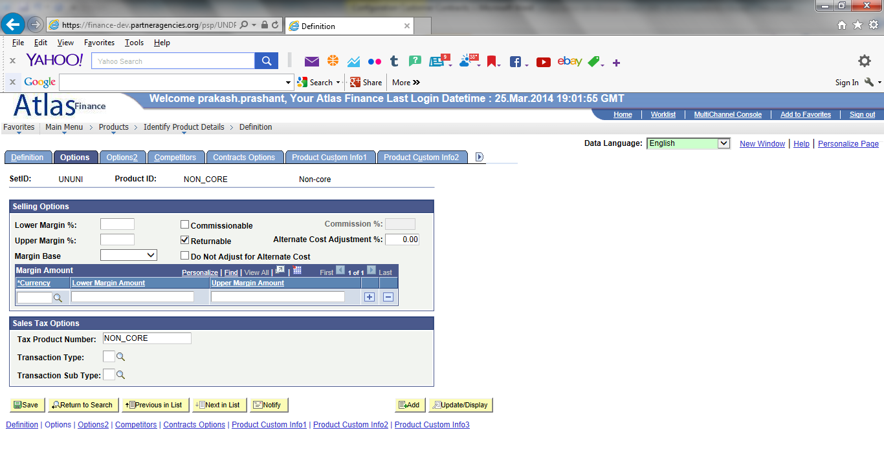

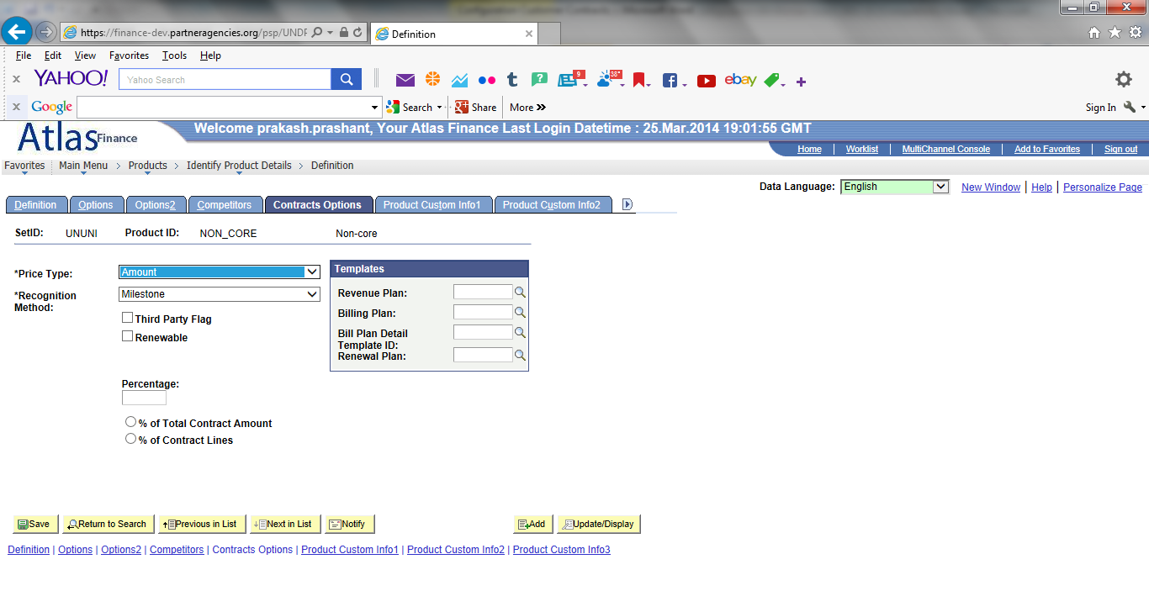

UNU specific Revenue & Billing templates have been set up (see separate document):

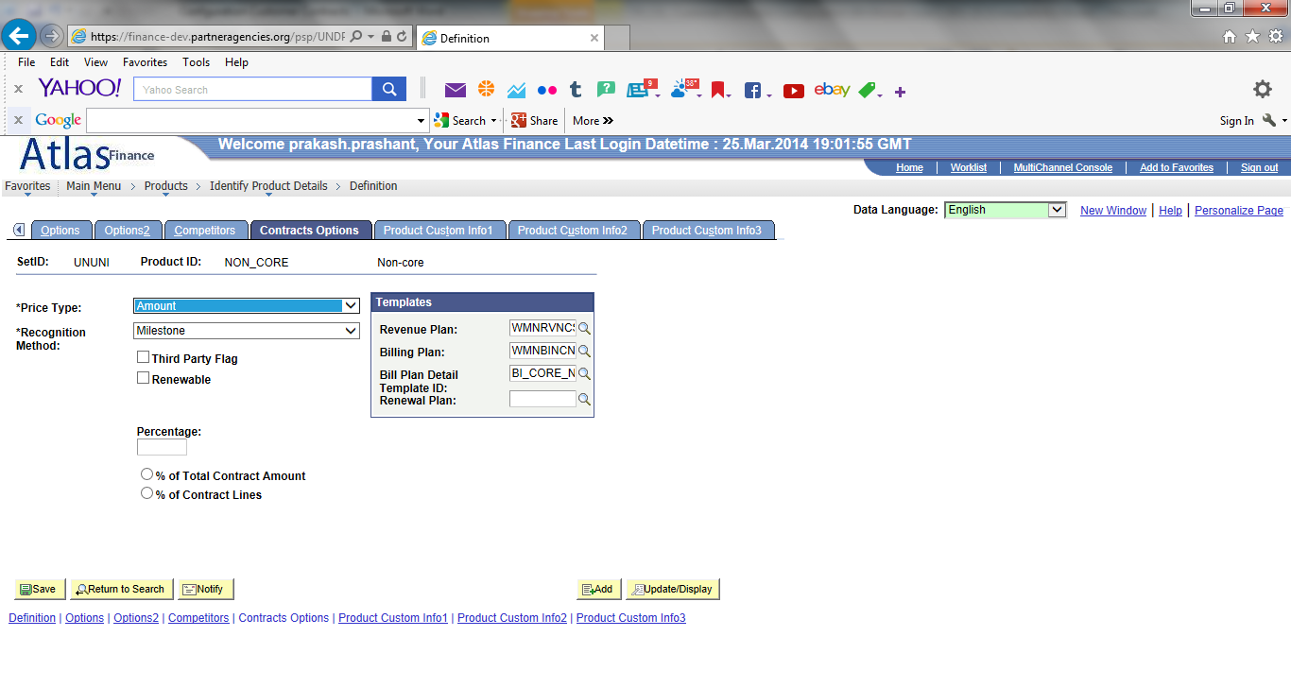

**Navigation: Set Up Financials/Supply Chain > Common Definitions > Products > Product Group Table:**

Set up Product Group for 4 products

Only NON_CORE displayed

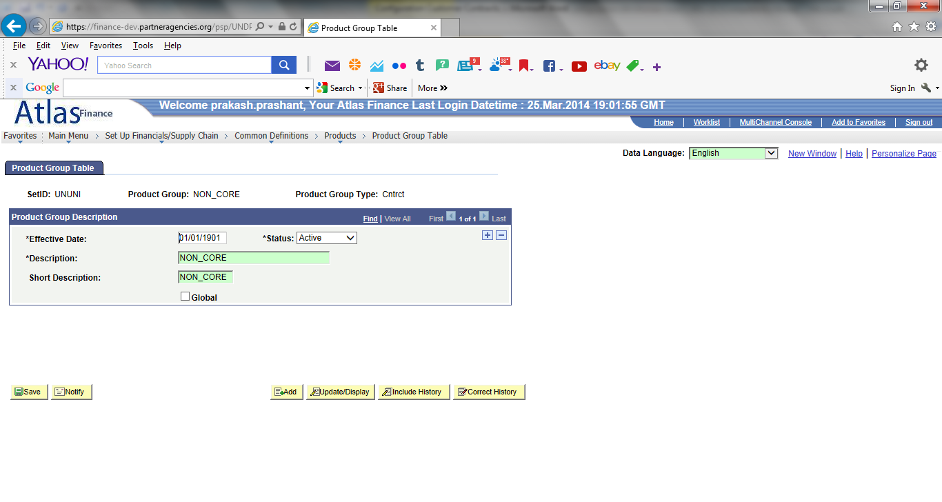

**Navigation: Products > Identify Product details > Assign Product Group:**

Assign product group for 4 UNU products:

Only NON_CORE displayed:

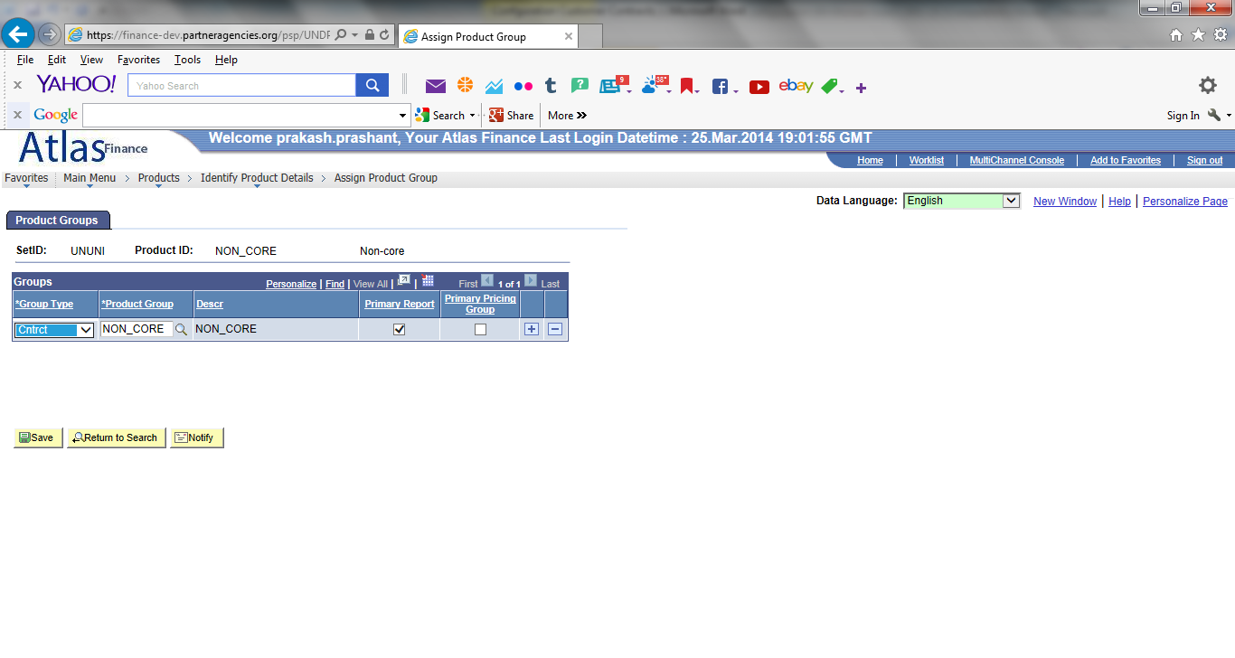

**Navigation: Set up Financials/Supply Chain > Product Related > Contracts > Contracts Product Options > Product Group Options:**

Set up for 4 UNU product groups:

Only NON_CORE displayed:

